Pokhara University

Level: Bachelor | Semester – Fall | Year : 2009
Programme: BE |  | Full Marks : 100
Course: Applied Mechanics (Dynamics) |  | Time : 3hrs.

Candidates are required to give their answers in their own words as far as practicable.
The figures in the margin indicate full marks.

Attempt all the questions.

1. | - A projectile is launched from point A with the initial conditions shown in the Figure. Determine the slant s which locates the point B of impact. Calculate the time of flight.  - The acceleration of a particle is defined by the relation a = - k/x. It has been experimentally determined that v = 5 m/s when x = 200 mm and that v = 3 m/s when x = 400 mm. Determine:  - The velocity of the particle when x = 500 mm.  - The position of the particle at which its velocity is zero. | 8  7
2. | - The two blocks shown start from rest. The horizontal plane and the pulley are frictionless and the pulley is assumed to be a negligible mass. Determine the acceleration of each block and tension in each cord.  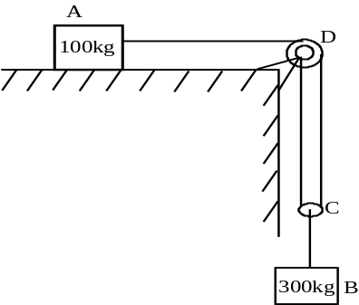  - A 600g ball a is moving with a velocity VA when it is struck by 1.2kg ball B which has a velocity VB of magnitude of 6m/s. Knowing that the velocity of B is zero after the impact and that the coefficient of restitution e = 0.80. Determine the velocity of ball A, (i) Before impact . (ii) after impact. | 7  8
3. | A 1.5 kg block B is attached to an undeformed spring of constant k = 80 N/m and is resting on a horizontal frictionless surface when it is struck by an identical block A moving at a speed of 5 m/s. considering successively the cases when the coefficient of restitution between the two blocks is e = 1 determine (a) the maximum deflection of the spring, (b) the final velocity of block A . 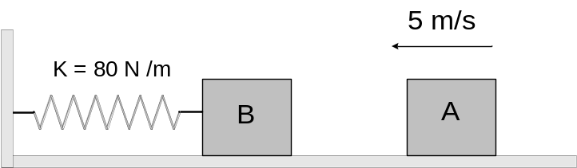 | 15
4. | A system consists of three particles P1, P2 and P3 at the instant as shown in the figure below. The particles are acted upon by the external forces. F1 = (10i-5j)lb, F2 = (-13j-20k)lb ;and F3 = (18i-12j+5k)lb and they have velocities of V1 = (5i+8j)ft/s, V2 = (3i-6k)ft/s and V3 = (3j-2k)ft/s respectively. For the mass centre of the system at the instant shown, determine the analytical expression of (i) its position vector r (ii) its velocity v, (iii) its acceleration a. | 15
5. | A mixing drum of 125 mm outside radius rests on two casters, each of 25 mm radius. The drum executed 15 revolutions during the time interval t, while its angular velocity is being increased uniformly from 20 to 50 rpm.Knowing that no slipping occurs between the drum and casters determine (a) angular acceleration of casters (b) time interval. | 15
6. | In the engine system shown in figure, the crank AB has constant clockwise angular velocity of 1800 rpm. For the crank position indicated, determine the angular velocity and angular acceleration of the connecting rod BD as well as the velocity of the piston. | 15
7. | Write short notes on (Any Two)  - Translation and rotation of rigid bodies  - Radial and tranverse component  - Central and oblique impact | 5×2

